**2019-20**

The activities of the year were formally began by introducing the club and its activities to the first year students at the induction programme conducted for the newly joined students.

The club was registered with the mobile app of Vimukthi mission .

On 26th June the International Day against Drug abuse was observed. 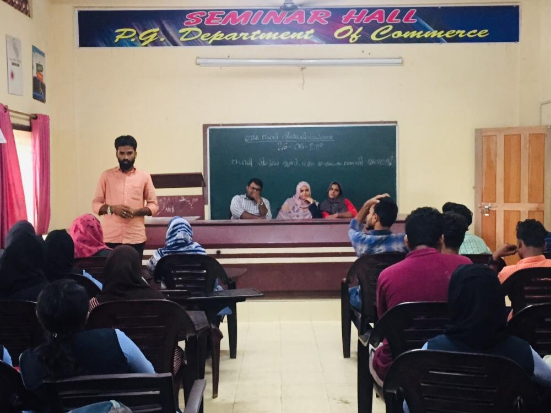

On 12 th Augest 2919, an awareness programme on the impacts of drug abuse was conducted in association with Vimukthi Mission of Kerala Govt.

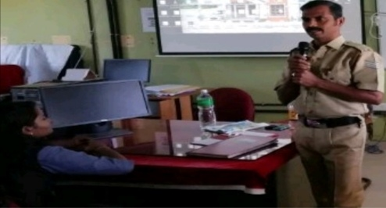

On 4th December 2019, all the students and staff of the college took anti drugs oath.

